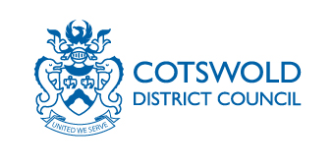

Hackney carriage/Private hire vehicle accident report

Data Protection Statement:
We will only use your personal information gathered for the specific purposes of your report. We will not give information about you to anyone else or use information about you for any other purpose, unless the law allows us to. Further privacy information can be found on our website.

Details of vehicle
Make: Model:
Reg No: Plate No:

Details of driver
Name: Badge No:
Address:

Details of accident
Date and Time:
Place:
Has the accident been reported to the Police?:
Please describe how the accident occurred and include any details of damage to vehicle and/or any injuries to persons (continue on separate sheet if necessary):

I am aware that I have to inform the Council of any convictions for driving offences.

Date: Signature:

When completed return this form to ers@cotswold.gov.uk

Remarks by Licensing Officer:

