Taxi Driver Application Checklist
Designed to make the application process easier in helping you collate your evidence to apply

* This is not the application form

Version: 1.0 - October 2022

Business Support (Licensing)
Environmental and Regulatory Services, Cotswold District Council, Trinity Road,
Cirencester GL7 1PX
Tel: 01285 623000 Email: ers@cotswold.gov.uk www.cotswold.gov.uk

Index

General Introduction 1
Right to Work in UK 2
Criminal Record Status 3
The Knowledge Test 4
Medical and Vision Assessments 5
Disclosure and Barring Check & Update Service 6
Driver and Vehicle Licensing Agency - Your UK Driving Licence 7
Safeguarding Training Course 7
Taxi Driving Assessment Test 8
Know Your Tax Responsibilities as a Taxi Driver 8
National Register of Refusals and Revocations (NR3) 9
English Proficiency 9

General Introduction

Use this checklist to help collate the evidence and information you need to support in making a successful taxi driver application. This is NOT the application form.

Its purpose is to reduce the chasing calls and emails because an applicant is unaware of evidence needs. ‘Cleaner’ first time application forms are also a key performance measure.

Follow this checklist in order. It’s likely you will be waiting for items to come through to you, so continue to the next step, as you wait.

Remember to come back and complete this checklist when information comes in to you.

The checklist is designed to help you prepare to complete a full application form.

You can also open our website as a guide as you go, as this document refers to many part of our site to support with further guidance. www.cotswold.gov.uk/taxiprototype

Right to Work in UK

I will confirm my right to work in the UK.

I have the legal right to work in the UK and my proof is:

UK passport ☐

Other accepted documents ☐

Please go to Right to Work in our step by Step Guide on our website to see what proof you need to hold. (give location on website)

Advice: your right to work will be checked at the final interview with the Licensing Officer. DO NOT continue to make an application for a taxi driver licence with Cotswold District Council if you don’t have evidence of the right to work in the UK. Your application must be refused by the Licensing Officer.

Criminal Record Status

I will confirm my criminal record:

- I have no convictions ☐

- I have convictions and I will list below in date order:

Offence | Date of Conviction | Court | Sentence

Please go to Criminal Record Status in our step by Step Guide on our website to see the information you must give if you have convictions. (give location on website)

Advice: Depending on the type nature and date of your convictions you may still be able to apply for a taxi licence in our area.

All convictions must be disclosed - there are no ’spent convictions’ in the case of taxi drivers. This is because of the nature of the work and a highly important aspect of public protection.

The Knowledge Test

Please go to Book your Knowledge Test and Find Out How to Prepare Well in our Step by Step Guide on our website to see how to book and pay for a knowledge test. It will also explain what to bring to your test, how to change a booked test and when you will get your results.

I have booked and paid for a knowledge test with Cotswold District Council for:

- PHLV knowledge test ☐

- Dual test (HC and PHL knowledge test) ☐

Test Type | Date of First attempt at Knowledge Test | Time | Location | Outcome
 |  |  |  | pass / fail

Receipt Number……………………………

Test Type | Date of Second attempt at Knowledge Test | Time | Location | Outcome
 |  |  |  | pass / fail

Receipt Number……………………………

If you failed your knowledge Test on your second attempt, you are unable to retake a test again until 6 months have passed from the date of your last test. It is worth noting when the first available date is for you to reapply to take your knowledge test.

Earliest date to rebook a knowledge test:

We do not advise moving forward with other checks at this point because your DBS check and medical checks are valid for a limited time period. You may want to start preparing a few months before you can take your test again.

Medical and Vision Assessments

Please go to Book your Medical and Vision Assessments - Fit to Drive in our Step by Step Guide on our website to see how to prove you are fit to drive the public.

I have booked an informal appointment with my GP to discuss any medical issues which may affect my medical examination report and ability to declare fitness to drive on:

Date / Time / Location:

I have booked and paid for a medical examination report assessment with:
- My GP with access to my medical history ☐
- OR a recognised company for an assessment, who have access to my medical history ☐
- Medical examination report assessment and Vision Assessment at same event ☐
- Medical examination report assessment ☐
- Vision examination report assessment (with an optician or ophthalmologist) ☐

Dates / Times / Locations:

Assessment Type | Date of Assessment | Outcomes: Fit to Drive / Unfit to Drive  (Include any action you will take to resolve reasons for a fail: vision correction / course of medication before reassessment)
Medical
Vision

Advice: There are number of items to take with you:
- Remember to also take the Medical Declaration Form for Cotswold District Council for the Medical Practitioner to sign at the time of your assessment.
- If you wear glasses or contact lenses when driving, wear them to the assessment.
- Take a copy of your prescription for vision correction to the assessment.
- You will need an ID to show the person carrying out your assessment.

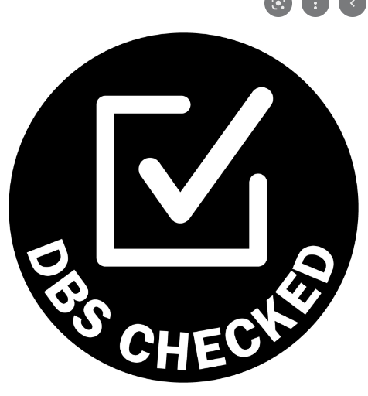 Enhanced Disclosure and Barring Check &

Update Service

Please go to Request an Enhanced Disclosure and Barring Check & Join the DBS Update Service in our Step by Step Guide in our website to prove you are a fit and proper person to drive members of the public.

I have signed up to and have paid for an Enhanced Disclosure and Barring Check:

You will need the following from us:

Organisation Reference: COTSWOLD (check and amend for WODC/FODDC)
Organisation Code: council

Date applied: | Date of confirmation: | Code:
Certificate Number:

You must also apply to sign up to the DBS update service when you make an application for a taxi drivers licence. We recommend that you do this at the same time as requesting your check. It is a requirement that your DBS status is in place at all times and if you let your DBS lapse your licence will be revoked. If you do not sign up to the update service immediately, you have only one month to do this.

I have signed up to and set up a monthly direct debit arrangement for The Disclosure and Barring Update Service.

Date applied: | Date of confirmation: | Code:
DD card used: (last 4 digits of long number) Expiry date:

Advice: make sure that the Direct Debit card you use to set up your DBS update service has funds each month to pay for the update.

Driver and Vehicle Licensing Agency –

Your UK Driving Licence

Please go to Driver and Vehicle Licensing Agency - Your UK Driving Licence
in our step by Step Guide on our website to see the information you must give about your driving licence.

I can confirm that I have held a full UK driving licence for 12 months or more.
- Yes ☐
- No (unfortunately, you are unable to continue with your application at this time) ☐

My driving licence shows my current home address

- Yes ☐
- No (You must get the address on your licence updated.) ☐

I have my DVLA licence check number:

DVLA Licence check number:

Safeguarding Training Course

Please go to Book a Safeguarding Course in our step by Step Guide on our website to see the information you must give about your driving licence. (give location on website)

I have booked a place on a Safeguarding Training Course recognised by Cotswold District Council (currently our recognised provider is Cheltenham Borough Council’s online course).
- Yes ☐
- No (unfortunately, you are unable to continue with your application at this time) ☐

Course Date: | Certificate Information:

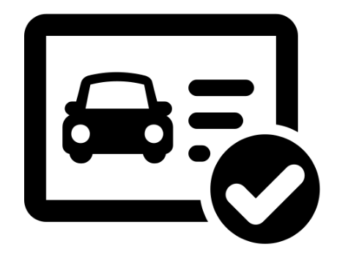 Taxi Driving Assessment Test

Please go to Book a Taxi Driving Assessment Test in our step by Step Guide on our website to see what you need to do to prove you are able to drive at the standard required for a taxi driver. (give location on website)

I have booked a place on a Taxi Driving Assessment Test recognised by Cotswold District Council (currently the recognised provider is Diamond Advanced Motorists).

- Yes ☐
- No (unfortunately, you are unable to continue with your application at this time) ☐

Course Date: | Certificate Information:

Know Your Tax Responsibilities as a Taxi Driver

Please go to Know Your Tax Responsibilities as a Taxi Driver in our step by Step Guide on our website to see the information you must make yourself aware of about your tax responsibilities.

I can confirm that I have read the information on the requirements to show how I arrange to pay tax on my earnings as a licensed taxi driver. I know that I will be expected to provide this information on the date of my renewal of licence for the whole of my trading year.
- Yes, I have read this information on ……………………………………

Advice: You must put into place arrangements to pay your tax on earnings from the start of your trading, this will be required for the whole year when you renew your licence. It is a statutory requirement placed on us as an authorising body to check this. Your licence will be revoked if you cannot prove your tax paid on earnings. Please be aware that this will be in place from April 2022 for all new and existing licensed taxi drivers.

National Register of Refusals and Revocations (NR3)

Please go to the National Register of Refusals and Revocations (NR3) in our step by Step Guide on our website to see the information you must make yourself aware of about the NR3 register. (give location on website)

I can confirm that I have read the information on the National Register of Refusals and Revocations (NR3). I am aware that Cotswold District Council will check this register to see if I have been refused a licence in another local authority or had my licence to drive a taxi revoked by another authority.

I am aware that if a match is found Cotswold District Council will contact this authority. I am also aware that my details will be entered onto the NR3 register if my licence is revoked or I am refused a new licence or at the time of renewal.

I am aware that only selective information about me will be stored on the NR3 and this entry is held for 25 years.

- Yes, I read this information on ……………………………………

English Proficiency

Please go to Evidence of English Proficiency in our step by Step Guide on our website to see the information you must give about your spoken English.

I am aware that I am required to show I have proficiency in spoken English and this is a requirement under our policy of granting Taxi Driver Licensing in Cotswold District Council.
I can provide evidence with a:

- GCSE (or equivalent) in a subject such as English Language or Literature. ☐
- A degree in a subject containing substantial English content ☐
- An NVQ or BTEC in a subject that requires its students to communicate well in English ☐

If you are unable to provide any of the above, you can use evidence from an:
- English Proficiency Test (you will need to book, pay for and pass a test)

Course Date: | Course Provider:
Certificate Information:

Your checklist information is now complete

Please go to The Taxi Driver Licence Application Form. All your information will help you to complete your application form quickly and accurately for the first time. The website also gives you essential information on what to include with your application form and options on how to get your form to us.

There is also a section What happens now your Application is with us?. This explains what happens to your application and when you are likely to hear from us.

Finally, there is a section which shows what you can expect to receive when your licence is granted. What to expect when your Licence is Granted

Keep your checklist information safe, you will want to refer to the information you have collected here when you come to renew your licence in a year’s time. Having all your information in one place will save you time.
If you would like to give feedback on how you found using this checklist, please send your comments by email to: ERS@Publicagroup.uk

General

Taxi Driver
Application Checklist

Trinity Road, Cirencester, Gloucestershire, GL7 1PX Tel: 01285 623000 www.cotswold.gov.uk

